PARADISE HOTEL BUSAN  RESERVATION FORM |  | KISM 2023  19~22, November. 2023 |  |  |  |  |  | 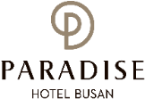
1. GENERAL INFORMATION |  |  |  |  |  |  |  | 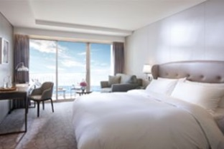  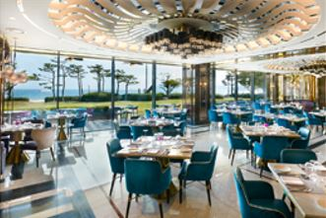  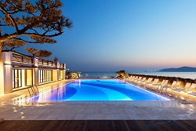
*Check-In Date: |  |  |  | *Check-Out Date:
*Name(Family/Given): |  |  |  | *Number of Persons:
*Telephone: |  |  |  | *E-mail:
2. CREDIT CARD GUARANTEE
*Credit Card: ☐Visa, ☐Master, ☐Amex(4Digital number: ), ☐Other( )
*Card Number: |  |  |  |  | *Signature:
*Expiry Date(mm/yy):
*Holder’s Name:
The above card information is used for the guarantee of your reservation only, and the payment will be made upon check-in.
I agree that using the above credit card information to be used in relation to cancellation fees and the occurrence of the No-Show.
상기 카드 정보는 예약 보증을 위해서만 사용되며, 결제는 체크인 시 이루어집니다. 위 신용카드 정보가 위약금 발생 시 사용하는 것에 동의합니다.
*SPECIAL RATE (UNIT: KOREAN WON)
Room Type |  |  | *Monday - Thursday |  |  | *Friday | *Saturday |  | *Sunday
Main Bldg. | Deluxe City View |  | ☐ 217,800 (King Bed)  ☐ 217,800 (Twin Bed) |  |  | Surcharge  +72,600 | Surcharge  +169,400 |  | Surcharge  +36,300
Annex Bldg. | Deluxe City View |  | ☐ 242,000 (King Bed)  ☐ 242,000 (Twin Bed)
Annex Bldg. | Deluxe Ocean View |  | ☐ 266,200 (King Bed)
Main Bldg. | Deluxe Ocean Terrace View |  | ☐ 290,400 (King Bed)  ☐ 290,400 (Twin Bed)
Annex Bldg. | Deluxe Ocean Terrace View |  | ☐ 314,600 (King Bed)  ☐ 314,600 (Twin Bed)
* Extra Bed(Main Bldg.), Extra Bedding(Annex Bldg.): KRW 72,600(Per Night)
* Breakfast Buffet (Main Bldg. 1F. On the Plate, 06:30-10:00): Adult(KRW 50,000), Child(KRW 35,000/ 48months~elementary schoolchild)
* Special Request:
* The rates above are non-commissionable, and they are Inclusive of 10% Service Charge and 11% Government Tax. (세금 및 봉사료 포함가)
* The rates above are not inclusive of breakfast. (조식 불포함)
* Number of guests: 2 Adults. All rooms of the Building are non-smoking areas.
* Check-in time is 3p.m.(15h00) Check-out time is 11:00 a.m.(11h00). Past the mentioned check-out time, the following rates will be applied
(Until 3p.m.(15h00): 50% of the room rate, After 3p.m.(15h00): 100% of the room rate)
* Benefits Included: Outdoor Ocean pool(Swimming pool), Fitness Club, Business Center, Paradise Kids Villages, Wi-Fi
* The Leisure facilities(Ocean Pool, Fitness Club, Sauna, Spa Cimer) will be closed for maintenance every fourth Wednesday each month. (넷째주 수요일 레져휴무)
CANCELLATION POLICY
* Amendaments, Cancellations are availble upon following regulations: Hotel has the right to claim all room charge, which would be deducted from your guaranteed credit card. Cancellation or No-Show after the room reservation is being charged as below:
- From 5days to 3days prior to Arrival date(~18:00): 50% of the Room charge (체크인 5일 ~ 3일 전 취소 시: 숙박료의 50% 위약금 부과)
- From 2days or less prior to Arrival date(Includling No-Show): 100% of the Room chrarge (체크인 2일 전 ~ 당일 취소시(노쇼포함): 숙박료의 100% 위약금 부과)
Please send your reservation form to: res@paradisehotel.co.kr (Tel. +82-51-749-2111~3)

